[Insert Logo]

COVID-19 SAFETY PLAN
AND CHECKLIST
[Surf Life Saving Club]

[Surf Life Saving Club]
[Club Facility Location]
[Club President]
Contact Email
Contact Mobile Number
Version
[Insert Name] is responsible for this document
Version 1.7 Sept 1 2020

Version Control Table
Date | Version | Details
12 June 2020 | 1.3 | Added registration and cleaning information to back of plan
19 June 2020 | 1.4 | Added Junior Development (nipper) checklist and Club Shed and Equipment Area Checklist to plan
10 July 2020 | 1.5 | Section 7, 8 and 9 added – Specific risks related to areas of Lifesaving, Education and Sport
31 July 2020 | 1.6 | Section 5 – COVID Safe Hygiene Marshal  Section 5, 11 & Attendance Sheet – QR code information added as NSW Government encourages clubs to use this system for attendance registration.  Section 11 – Resource links added  Section 2 – Becoming a COVID Safe Business
1st Sept 2020 | 1.7 | Updates to Junior Activity Plan

Table of Contents
1. Introduction 3
2. Key Principles 3
3. Responsibilities under this Plan 4
4. Criteria for facility operating 4
5. Facility/Key Principles Checklist 5
6. Junior Activity Checklist 10
7. Lifesaving and Patrol Checklist 12
8. Education Checklist 13
9. Surf Sport Training Checklist 14
10. Suspected/Confirmed case within the clubhouse 15
11. Supplies and Resources 16
12. Safety Promotional Material 17
13. Cleaning Information 24
[Club Name] Attendance Register 26

- Introduction
The purpose of this COVID-19 Safety Plan is to provide an overarching plan for the implementation and management of procedures by [Surf Life Saving Club] to support its members and participants in clubhouse activity.
The arrangements set out in this plan are intended to prevent the transmission of COVID-19 among members, participants, coaches, officials, administrators/volunteers, visitors, families and the broader community. The Plan provides the framework to govern the general operation of [Surf Life Saving Club], and the facilities it controls.
This Plan includes, but is not limited to, the conduct of:
  - club operation and activity; and
  - facility management and supporting operations (facility operations).
At all times the Plan is subject to all regulations, guidelines and directions of government and public health authorities. https://www.nsw.gov.au/covid-19
This template will be reviewed by SLSS on a regular basis. It is important to note, it is the club’s responsibility to ensure the club’s COVID Safety Plans are kept up to date and that they meet the relevant legislative and compliance requirements.
- Key Principles
This Plan is based on:
- AIS COVID framework
- Fitness Australia guidelines for gyms
- NSW Clubs guidelines for the use of bars

The Plan also accepts as key principles that:
- The health and safety of members, participants, coaches, officials, administrators/volunteers, visitors, families and the broader community is the number one priority;
- Members, participants, coaches, officials, administrators/volunteers, families and the broader community need to be engaged and briefed on [Surf Life Saving Club]’s plan;
- Facilities are assessed and appropriate plans are developed to accommodate upgraded hygiene protocols, physical distancing and other measures to mitigate the risk of transmission of COVID-19.

Being COVID Safe
- You MUST create and complete a COVID-19 Safety Plan
- Register your club as a COVID Safe Business - https://www.nsw.gov.au/register-your-business-as-covid-safe
- Show that your club is COVID Safe by doing the following:
- Download and display your COVID Safe posters and make your customers feel confident
- Consider using a contactless method such as a QR code Myguestlist (example) to collect customer details for contact tracing
- Share your completed COVID-19 Safety Plan with your staff and members to ensure their wellbeing
- Display your COVID Safe badge on your digital and social channels such as Facebook and Google Maps
- Train staff and members to act in a COVID Safe way
Keep your plan up-to-date when there are changes to the rules. Customers can visit the URL in the posters to provide feedback on how your business is providing a COVID Safe environment.
- Responsibilities under this Plan
[Surf Life Saving Club] retains the overall responsibility for the effective management and implementation of the activities and operations outlined in this Plan.
The Board of [Surf Life Saving Club] is responsible for:
- Approving the Plan and overseeing the implementation of the arrangements in the Plan; and
- Revising the Plan as required, ensuring it reflects up to date information from government and public health officials.
The Board has appointed the following person as the [Surf Life Saving Club] COVID-19 Safety Coordinator to execute the delivery of the Plan and to act as a point of contact for information relating to this Plan:
Name | [XXXX]
Contact Email | [XXXX]
Contact Number | [XXXX]
[Surf Life Saving Club] expects all members, participants, coaches, officials, administrative staff and volunteers to:
- Comply with the health directions of government and public health authorities as issued from time to time;
- Understand and act in accordance with this Plan as amended from time to time;
- Comply with any testing and precautionary measures implemented by [Surf Life Saving Club];
- Act with honesty and integrity in regard to the state of their personal health and any potential symptoms; and
- Monitor their health and take a cautious approach to self-isolation and reporting of potential symptoms.

The Surf Club COVID Safety Coordinator will:
- Complete the COVID Safe Checklist and Plan (reviewed at coordination meeting)
- Distribute safety posters throughout the club (provided by SLS Sydney)
- Purchase and distribute hand sanitation material for use at entry and exits
- Update plan when required
- Act as a contact for members regarding ideas and questions
- Develop strategies to check on maximum numbers and distancing requirements
- Define and develop cleaning strategies with club management
- Criteria for facility operating
Surf Life Saving Clubs in Sydney can open from 13 June 2020 under the following guidelines:
- Have appointed a Club COVID Safety Co-ordinator

- Have attend the SLS COVID Safe Briefing/ Meeting and been inducted into the safety framework

- Have completed the safety plan and checklist for each area opening (club, showers, gym, bar)

- The management committee are satisfied they meet the required guidelines within this plan

- Facility/Key Principles Checklist
Each area of the club will require common safety measures, these include:

Numbers, distancing and registration
- Considering having one entry and one standard exit to the club to allow for registration and promotional information etc.

- Capping numbers of entry to one person per 4 metre square for the floor space used

- Groups can only be a maximum of 10 people – no more than 10 people using a table

- Compulsory registration of those using area (tag or sign in) for possible contact tracing. Clubhouse entry via a tag system may be suitable. Club to define if they need a section sign in system or a club entry system.

- As of 25 July QR code sign-in is strongly encouraged by NSW Government.

- Monitor and call out / discourage physical greetings (hand shaking, high fives, hugs and kisses, etc).

- Encourage members not to loiter in high use areas ‘Get in, train and get out’, “Shower and leave”

Cleaning and Hygiene
- Hand and hygiene sterilisation available on entry and exit

- Provide self-cleaning guidelines for members where required

- Develop monitoring process for compliance and cleaning

- Discourage sharing of equipment and clean between use

- Advise that no bags, clothing (including wetsuits, etc) or other personal items are to be left at the club or in change rooms.

Information and safety promotion
- Safety promotional posters and material should be displayed

- Provide guidelines in club news, social media and other channels, of club usage requirements

- Brief club officers, coaches, team managers and sections heads about this plan

- Members identified as high-risk groups of COVID-19 should be strongly encouraged to stay home.

- If a member tests positive to COVID-19 they’re strongly encouraged to contact the Club President and state date and times they were at the premises (these details are to be kept confidential).

The following checklist should be used for each specific area
Showers and change rooms
It is strongly advised that members change and shower at home and a adopt a “Get in, train and get out” policy.
- Club to define the maximum number that can be accommodated using one member per 4 square metre rules. Note this number on posters supplied, undertake inspections and encourage member to member accountability. Record any breaches or actions taken for non-compliance.
- Promote and monitor social distancing of 1.5m. Consider helpful “X” tape on floor systems and/or safety signage displayed promoting distancing.
- Define process for entry. User tracing is important if an infection is identified. Ensure you have a system to identify members using the clubhouse such as using the club electronic tag system or including a sign in process to enter. Display signage provided
- Provide hand sanitation on entry and exit
- Supply cleaning products and encourage members to self-clean surfaces used.
- Clubs must ensure a regular cleaning protocol of showers and change rooms after each group use.
- Advise the use of own towel and personal care products – safety signage provided
- Set up a cleaning schedule and record sheet located in each bathroom/change room and ensure cleaners record each facilities clean (template attached).

Gym
- Club to define the maximum number that can be accommodated using one member per 4 square metre rules. Note this number on posters supplied, undertake inspections and encourage member to member accountability. Record any breaches or actions taken for non-compliance.
- Promote and monitor social distancing of 1.5m on all equipment – safety signage provided. You may configure equipment to include spacing or encourage members to use equipment leaving spacing as required
- Define process for entry. User tracing is important if an infection is identified. Ensure you have a system to identify members using the clubhouse such as using the club electronic tag system or including a sign in process to enter. Display signage provided
- Provide hand sanitation on entry and exit and encourage personal hygiene via poster
- Inform members they must have their own towel – poster provided
- Discourage members from using equipment between sets
- Supply cleaning products to promote self-cleaning of each item of equipment after use – poster provided
- Clubs must ensure regular cleaning of gym and equipment. For heavily used areas, this is recommended to be several times a day.
- Encourage member to member accountability where members self monitor and provide safety information to other members who do not comply. Provide advice and encouragement in newsletters – see something, say something!
- Consider using a booking system for the gym such as Acuity Scheduling etc Acuity Scheduling or Picktime which are free software programs.

COVID-19 Safe Hygiene Marshal for Gym

As of Saturday 1 August 2020 the NSW Government has made the following mandatory.

Under the requirements of the NSW Health gym usage guide, a COVID-19 Safety Hygiene Marshal must be appointed for the safe operation of the club gymnasium.

The Marshal should be inducted into the club’s gym safety requirements and gym safety plan. The club will determine how this system operates (roster system, coach appointment for group workouts, time slots etc)

The COVID-19 Safety Hygiene Marshal will:
- Ensure compulsory COVID Safe registration of gym users
- Have an understating of the club’s COVID Safety Plan and gym requirements checklist
- Be present when others are using the gym
- Be identified by distinctive clothing (such as a vest, shirt or badge)
- Oversee all aspects of the COVID-19 Gym Safety Plan and ensure requirements are being adhered to including social distancing, cleaning and ensuring the accuracy of record keeping.
- Provide guidance, advice and sanctions to gym users, and to enforce safety hygiene requirements set by the club.
- Checklist for Hygiene and Cleaning of Indoor Recreation Facilities

Club Shed, Multi-Purpose Rooms and Equipment Areas

- Ensure the number of people in a facility does not exceed one person per 4 square metres.

- Minimise co-mingling by staggering training start times.

- A register must be completed by anyone entering the facilities and records kept for 28 days.

- Promote and monitor social distancing of 1.5m. Consider helpful “X” tape on floor systems and/or safety signage displayed promoting distancing.

- Ensure signage is displayed around hygiene and cleaning protocols.

- Consider using a booking system for training sessions.

- Adhoc use of clubhouse facilities by members outside of formal or group training sessions is prohibited due to lack of ability to monitor cleaning and hygiene protocols.

- Where there is a group working on equipment or cleaning out the gear shed or club house, for example, use a booking system to keep numbers at a minimum and schedule small groups to work at different times.

- Operate on a “Get in, train or work, and get out” basis.

- Prevent gatherings occurring outside the premises.

- Consider appointing a Club house manager to oversee bookings and usage.

- Ensure regular cleaning of communal areas and wipe down of any equipment being worked on.

- Provide hand sanitiser and encourage use on entry and exit.

- Provide detergent and gloves for members working within the facility.

- Any shared sports/training/CPR equipment must be washed down and disinfected after each use.

- Ensure you appoint someone to oversee cleaning of shared equipment, either an overall Clubhouse and gear manager or appoint someone from each training or working group.

- The storage of personal craft within the gear shed is discouraged at this stage.

- Facilities can open under the above guidelines from 13th June. Return to full training activities including boats and double skis are able to resume from 1st July.

- IRB training can resume now under the Emergency service provision of essential training.

Club Bar

- Club to define the maximum number that can be accommodated using one member per 4 square metre rule. Note this number on posters supplied, undertake inspections and encourage member to member accountability. Record any breaches or actions taken for non-compliance. Bar staff to monitor

- The NSW Clubs guidelines note that alcohol can only be consumed by members/visitors seated

- Consider helpful processes for members to maintain social distancing of 1.5m
  - Space out tables and chairs
  - Use tape to indicate standing locations for the bar queue
  - Display posters

- Visitors must sign in when entering the bar. While member details will already be recorded in Surfguard in case of the need to contact. Visitors (non-members) should have their name, number and email address recorded

- Encourage COVID Safe App – poster supplied

- Provide hand sanitation on entry and exit

- No shared food or utensils to be provided on tables. Do not have items that have multi use such as menus, sugar bowls, toothpicks etc. Napkins and straws must not be stored in communal areas or on tables

- Provide regular cleaning down of surfaces by bar staff and avoid cross infection by using the same cleaning cloth without regular washing in hot soapy water – or use paper towel and discard.

- Groups can only be a maximum of 10 people – no more than 10 people using any one table

- Ensure bathrooms are well stocked with hand soap and paper towels. Poster with handing washing information provided.

General Information to members at entry points and in newsletters
To assist us to create a COVIDSafe Surf Club please follow safety signage and the guidelines below:
- Register entry via electronic tag, sign in book or QR code sign-in
- Maintain Social distancing – 1.5m
- Personal hygiene encouraged
- Use hand sanitation on entry and exit
- Observe maximum number signage and guidelines
- Download and turn on COVIDSAFE App
- Self-clean surfaces used with product provided
- Call the club president if you are diagnosed with COVID-19 after attending the club
X Don’t enter if you are feeling unwell
X Don’t congregate in groups or share equipment. Do not leave bags, cloths or wetsuits within the club.

- Junior Activity Checklist
Pre-Season
- Add this JDC safety checklist to the club COVID Safety Plan.

- Appoint a COVID Safety Officer to oversee Junior Activity/Training. Appoint additional officers for larger group numbers (use one officer per 50 nippers). Check in with club COVID Safety Officer(s)

- Complete your Junior Activity COVID Safety Plan and submit to council for approval or consider a district approach for liaison. This must be done prior to commencing the season.

- All COVID plans should be very defined, and include maps, roles and responsibilities, and direct contact points with mobile numbers
- Develop a nipper registration process that does not involve large gatherings. Consider online registration and/or small groups rostered at different times.

- Communicate safety arrangements to your club members and the greater community prior to the start of the season. Consider a communications plan to promote your safety procedures and culture. This can be done via your website, during registration, club Facebook, Instagram, local newspaper, club and perhaps by liaising with local schools, who could share your information.

Training
- Ensure all age managers hold the SLS Age Manager Award and are qualified for water safety. Encourage parents who would like to be on the beach with their children to obtain their age manager award.
- Has all internal club COVID training been completed prior to season start?
- Is everyone aware of First Aid and Rescue updates regarding COVID?

Suggestions
Define the group management plans. Consider the following :
  - Staggering start times/days/season dates for different age groups
  - Limiting overall Nipper numbers or cancelling particular age groups
  - Keep nippers moving and not gathering together
  - Scheduling age groups on alternate weeks (ie each group participates once per fortnight)
  - Consider different points of drop off and pick up

Day(s) Prior to Activity
- Communicate your plans in advance to age managers, members, nippers and parents for the day’s activities so everyone knows exactly where to go, the registration process, what is expected of them etc.
- If you live in an “Area Hot Spot” in Sydney as per NSW Health Data – Hot Spot is a Green Area as per the NSW COVID Heat Map, as per the link below, then we request you seriously consider not attending Nippers until this area is not classed as Green https://www.nsw.gov.au/covid-19/find-facts-about-covid-19
- A parent management plan should be considered to manage parents on the day - what are they doing, where are they going - maybe even organise a walk for them?

On-Day Activity
Following the government requirements for a community sporting activity (indoors or outdoors) that involves a gathering of more than 20 participants https://sport.nsw.gov.au/novel-coronavirus-covid-19 :
- The gathering must not exceed a total of 500 participants, which includes:
  - a person engaged in the sporting activity, and
  - an official (including a volunteer) involved in the conduct or organisation of the sporting activity, and
  - a spectator of the sporting activity.
- Undertake a pre-activity safety briefing to communicate to age managers plan details
    - Ask members, parents and age managers who do not feel well NOT to participant and leave
    - Provide a registration process - ensure everyone has signed in – either QR Code Myguestlist or sign on sheet. Records are required to be kept for 28 days
    - Provide hand sanitation on beach entry and exit and encourage personal hygiene - ensure everyone has hand sanitised
    - Promote and monitor social distancing of parents, spectators and age managers of one person per 4m².
    - Encourage parents not to gather in groups and request face masks to be worn if unable to social distance
- Ensure age managers, adults assisting on the beach and water safety personnel are suitably identifiable through a vest, club shirt, hat or rash vest.

Nipper Competition Zones
- No contact between zones including water safety and equipment
- Zones need to go all the way to the water and be distinctly marked
- Use of bunting/barricades to separate Nipper Zones.
- Using alternative locations if necessary and approved by council
- COVID marshals at entry point and within the zone – identified by club shirt, hi viz vest, badge or cap
- Direct separate entry and exit points for zone.

- To adhere to Public Health Order requirements during Nipper activity you may need to consider implementing extra measures. Some suggestions include:
- Limiting the number of areas operating on the beach or the club house.
- Allowing additional time between age groups and/or activities to ensure there are no more than 500 people onsite at any one time.
- Encourage participants not to spend additional time in the area. - ‘Turn Up, Participate, Leave’
- Encourage only one parent/carer to accompany their child to the beach for the purpose of supervision.
- Safety officer to monitor gatherings and actively intervene to change behaviour as required

Post Day Activity
- Undertake post activity safety briefing and update plan as required

- Lifesaving and Patrol Checklist
- Review Section 5 Key principles of this plan
  - Numbers, distancing and registration
  - Hygiene and sanitation
  - Information and promotion

- Contact with Patients and members of the publics during rescues
- Use a bag-valve-mask (BVM) where possible as safer alternative
- Resuscitation masks with a one way valve may still be used following individual risk assessment or a lifesaver may perform compression only CPR.
- Maintain a safe distance while checking breathing

- Regularly clean rescue-ready equipment and contact points of rescue equipment used during rescues and wash hands and contact points after use.

- Use of Radios – make sure radios are in bags

- Oxygen Equipment
- Clean non-disposable parts of the unit thoroughly
- Use single only equipment

- First Aid Equipment
- Wear Gloves when handling any first aid equipment
- Do not used first aid equipment that is clearly damaged or used where possible

- Education Checklist
- Review Section 5 Key principles of this plan
  - Numbers, distancing and registration
  - Hygiene and sanitation
  - Information and promotion

- Clean areas used for practical training including but not limited to CPR training with detergent and disinfectant before and after each use.

- Ensure all trainers, assessors and facilitators are able to disinfect CPR manikins safely, and;
- they are aware of disinfecting protocols
- have access to disinfectants, gloves and alcohol wipes

- Ensure all trainers, assessors and facilitators deliver CPR training safely
- Avoid high risk activities when training CPR
- Make sure radios are in bags

- Ensure training rooms or areas are set up safely to avoid the risk of spreading COVID-19

- Implement measures to prevent crowding at ocean baths, such as limiting the number of swimmers to 3 per lane and ensuring physical distancing for swim training or entry-requirement swims (which can have up to 20 participants).
- Display signage at ocean baths that indicates 3 swimmers per lane
- Stagger pool entries during swim training
- Where possible, mark areas for pool entry and exits, and the direction of pedestrian traffic to avoid gatherings and promote physical distancing

- Schedule training with staggered start times and limit enrolments to a maximum of participants in a classroom with a trainer, assessor or facilitator

Reference SLSNSW COVD-19 Training and Education template for more information on the requirements and actions in Training and Education.

- Surf Sport Training Checklist
- Review Section 5 Key principles of this plan
  - Numbers, distancing and registration
  - Hygiene and sanitation
  - Information and promotion

- Have strategies in place to prevent surf sports spectators or participants from co-mingling between groups.
- Communicate on club webpages and through social media channels areas for spectators to gather safely as well as how they should move between places to avoid gatherings and maintain safe physical distancing eg., advise spectators where and how is best to park and congregate before, during and after a surf sports or training event.
- Move or block access to equipment to support 1.5 metres of physical distance between people.

- Sports equipment hygiene
- Clean any sports equipment before and after use while wearing gloves
- Encourage participants not to spit or cough, especially around others, as this can spread the virus and may be perceived as intentional which has consequential government penalties

- Sports training groups
- Encourage everyone to bring their own water bottle, sunscreen, sweat towels, exercise mats and equipment.
- Log training attendance—Record and keep names and contact details of all attendees (to be maintained securely for no less than 28 days). On request you will be required to provide the information to the Chief Health Officer.
- Take care around vulnerable people
- Training groups should practice social distancing and have no more than 20 participants, plus the instructor and any assistants, per space and comply with one person per 4 square metres of space

- Sports training in the gym
- Communicate on club webpages and through social media channels the safe capacity limits of the club gym and conditions of gym entry.
- Let everyone know that there is updated gymnasium form templates available on SLS Members Area Document Library (WHS) to align with new COVID-19 restrictions.
- Move or block access to equipment to support 1.5 metres of physical distance between people.
- Restrict gym entry to up to 20 members if the space safely allows within the limits of a safe area capacity (One person per 4 square meters of space)

- Suspected/Confirmed case within the clubhouse
Exclude members or staff who are feeling unwell
Provide information on the nearest testing site.

Testing site is located at: _______________________________

If a member tests positive to COVID-19 they’re strongly encouraged to contact the Club President and state date and times they were at the premises (these details are to be kept confidential).

If a confirmed case of COVID-19 has been identified and they have used the clubhouse, close the facility for cleaning.

Monitor the welfare of the member and check with the member if they have contacted NSW Health and if contact tracing is underway.

Contact the NSW Health helpline on 1300 066 055 to check advice and to check if contact tracing is required from a club level. If required notify members as appropriate.

The required sections of your clubhouse will need to be thoroughly cleaned and disinfected before people can return. Some Safe Work Australia guidelines include:

- Using an ISO accredited cleaner is not required
- Fogging is not required and is not recommended
- Swabbing surfaces following disinfection is not required

For more information on what to do if there is a case of COVID-19 see our infographic - What to do if a worker has COVID-19.

https://www.safeworkaustralia.gov.au/sites/default/files/2020-04/COVID-19-Infographic-Suspected-or-Confirmed-Cases-a3.pdf

- Supplies and Resources
General reference guides and assistance

Policy and Compliance – Peter Agnew, President SLS Sydney. 0407 938 880

Resourcing, guides and poster reprints - Karen Byron, SLS Sydney, Club Development Officer
9019 0722 or 0466 630 643 – clubdevelopment@surflifesavingsydney.com.au

Other useful COVID-19 Links
NSW Health Infection control guidelines for Community Sport
NSW Gov Guidelines for Sports-Recreation-Safety Plan
QR code sign-in details
Register your business as COVID safe
COVID-19 Safety Hygiene Marshal

Hand Sanitiser
Suppliers such as Bunnings, Chemist Warehouse. Refer to cleaning and hand sanitiser information.

Cleaning
See Safe Work Australia website for cleaning to prevent the spread of COVID-19
Safe Work Australia - COVID-19 workplace cleaning and disinfection
Download the PDF

How to calculate the number of people for the size of your room
- Measure the length of the room.
- Measure the width of the room.
- Multiply the length by the width to calculate the area of your room in square metres.
- Divide the area of your room (calculated in square metres) by 4 to calculate the maximum number of people allowed.
Number of people | Minimum space required
1 | 4 square metres
10 | 40 square metres
20 | 80 square metres
30 | 120 square metres
40 | 160 square metres
50 | 200 square metres

- Safety Promotional Material
Posters have been developed by Surf Life Saving Sydney and four printed A3 copies of each poster will be supplied to each surf club.

Welcome! Poster to be displayed at each entry point of the surf club.

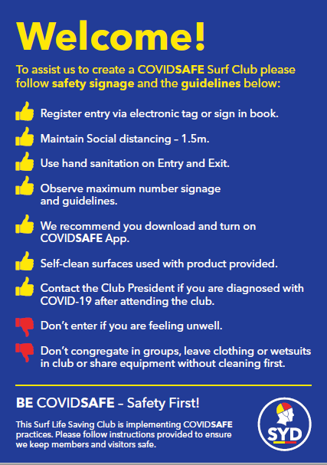

Attention Poster to be displayed at each entry point of the surf club.

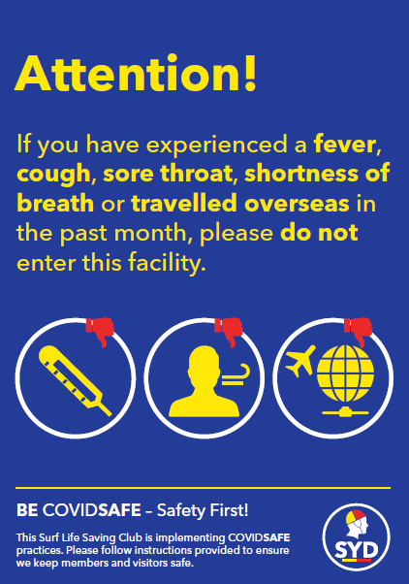

Maximum Capacity poster should be displayed at the entry to change rooms/showers, the gym and the bar. Write the maximum number of people allowed to enter based on one person per square metre (see Section 7)

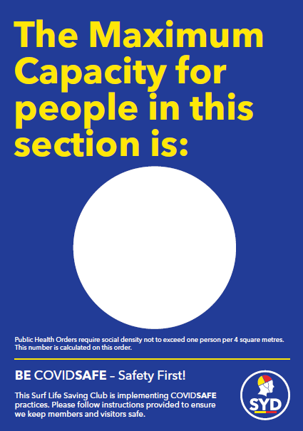

Gymnasium Poster to be displayed at entry to the gymnasium. Indicate the maximum number that can enter based on the one person per 4 square metre rule

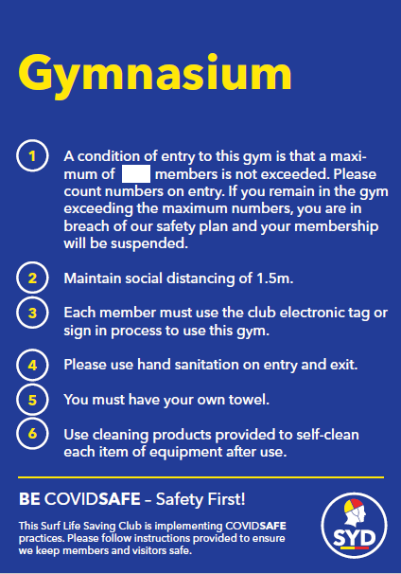

Shower and Change Room Poster to be displayed at entry of male and female change rooms. Indicate the maximum number that can enter based on the one person per 4 square metre rule

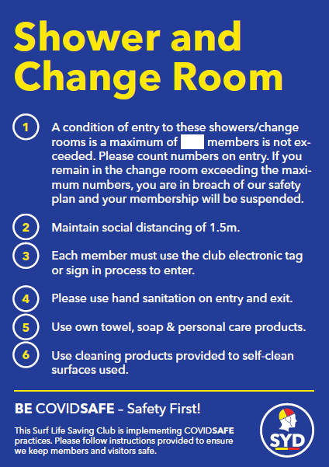

Club Bar Poster to be displayed at entry and inside the club bar. Indicate the maximum number that can enter based on the one person per 4 square metre rule.

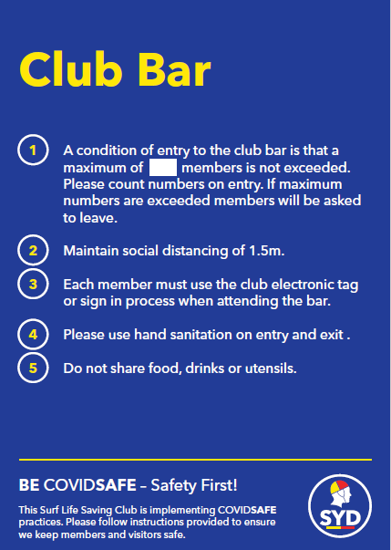

Good Hygiene Poster – to be displayed in bathrooms and toilets
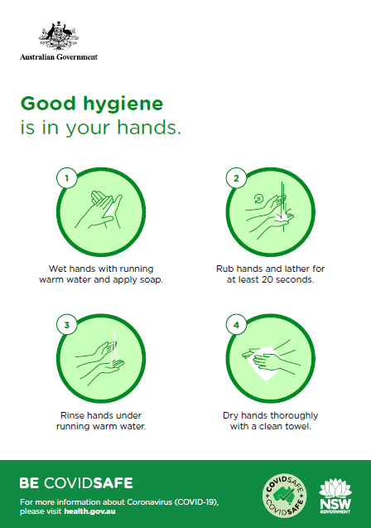

- Cleaning Information
Cleaning & Hand Sanitiser Information

As discussed, here is the information I collected so you have an idea of the varying prices on Hand Sanitiser out in the market place.

I did not dig down into general cleaning products as I thought your club would most probably have this already sourced, however LAB6, Bunnings, Officeworks and supermarkets all have a variety of products with various pricing on offer.

LAB6 Pty Ltd – 9540 2616 (Unit 17B, 1 Endeavour Road, Caringbah)
$53.90 for 5ltr Hand Sanitiser = $10.78 per litre
LAB 6 Full Price List

idc Medical - 9587 0232 (3 Production Avenue, Kogarah)
$125.00 for 5ltr Hand Sanitiser = $25.00 per
idc Medical Full Price List and idc Medical Product Flyer

Paul Cooper – Secretary Burning Palms
The Intellectual Disability Foundation of St George
0412 532 863
Bulk Hand Sanitiser – produced by Manildra Group @ $6.00 per litre

Retail Outlets - Prices as at 16th July 2020

Bunnings Warehouse
from $12.00 per litre

Chemist Warehouse
from $14.49 per litre

Officeworks
from $19.90 per litre

Cleaning schedule – Toilets, showers and change facilities

CLUB:
LOCATION:
DATE:
Area | Time | Time | Time
Sanitise and wipe down sinks and taps
Sanitise and wipe down toilets
Sanitise and wipe down communal touch points – door handles, hand dryers, light switches, bin lids.
Spray and wipe surfaces and benches
Mop floors

Check no personal belongings left
Top up hand sanitiser, soap, paper towel, toilet paper, spray sanitiser bottles

Checked and signed by facilities / club house manager or cleaner

[Club Name] Attendance Register
Register of attendees

Activity: _______________________________________ Location: ____________________________________________
Date: ______________

Arrival time | Departure time | Full name | Phone | Email address | Club | Role | In the previous 14 days, have you:  - Had any COVID-19 symptoms?  - Been in contact with any confirmed/suspected COVID-19 case?  - Travelled internationally? | Downloaded and using COVIDSafe app?
Consider collecting customer details for contact tracing with a contactless method such as a QR code will help keep customers and staff safe.
https://www.nsw.gov.au/covid-19/covid-safe-businesses/qr-codes-and-contactless-record-keeping

