Cover Sheet

Clubname SLSC

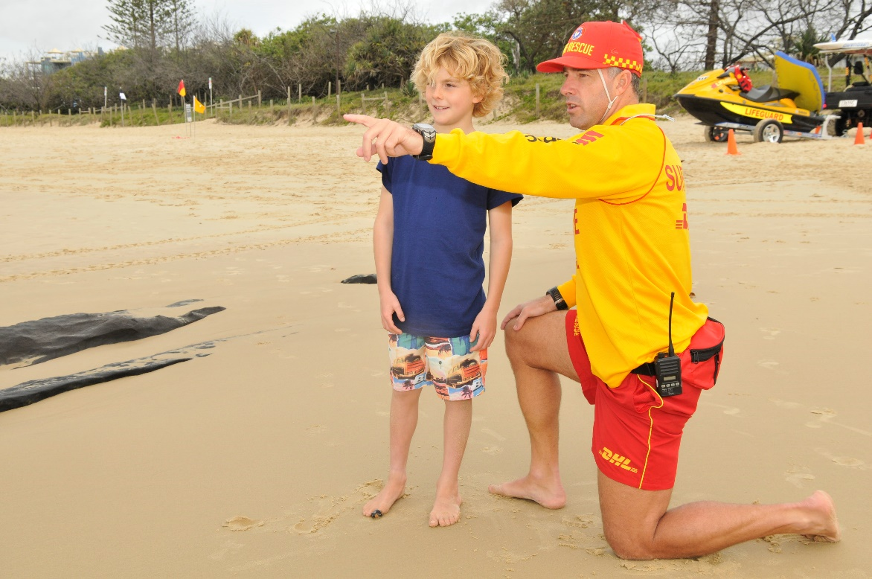

SLSS Premier Club of the Year

Season 2015-2016

Section 1 – Essential Information

- Club Name
Address and contact details

- ABN
ABN

- Contact Details of Person responsible for nomination
Name
Address
Phone
Email

- Scanned copy of the Affiliation Form
Attach a copy of the affiliation form to this submission

- Strategic / Operational Business Plan
Attach a copy of the Plan – see separate template at end

Section 2 – Criteria
- Continuous Improvement
Clubs should demonstrate how they have accessed and implemented a continuous improvement program such as the ASC Club Development Resources, State Department of Sport and Recreation club improvement program, an SLS improvement program or another identified improvement program
Put some information here about what Continuous Improvement Program you have participated in (ie SLSNSW Quality Program).
Program Name:
Level Achieved:
Status achieved:
Compliance Status:
Copy of the Status sheet / Action Items:
SLSNSW Quality program description below:
Surf Life Saving NSW is dedicated to best practice operations and compliancy both on and off the beach. There are three levels in the program which clubs can become accredited in - Bronze, Silver and Gold.

Levels

Bronze status
- Ensures that clubs are fulfilling the requirements under the Fair Trading NSW, the Office of Liquor Gaming and Racing, SLSNSW, SLSA and the Australian Charities and Not-For-Profit Commission
- Provides increased credibility with local council, the public and government bodies
- Creates an environment where quality is highly valued and acknowledged as the norm within the club
- Provides quick and easy reference and identification of best practice operations in financial management administration, members services, lifesaving operations and club management
Each season clubs can complete all items within the Bronze level, including the compliance components from SLSNSW and relevant Government bodies.
Detail how you have implemented this program and initiated improvement activities based on your involvement
Item | Description | Actions Taken

- Our Improvement Program
Clubs will further demonstrate the use of a systematic improvement program that focuses on two or more of the following: Leadership; Planning; People; Member Focus or Overall Performance.
Area | Area for Improvement | Actions taken | Outcomes
Leadership
Planning
Member Focus
Overall Performance

- Strategic Achievements – 2020
Clubs will evidence achievements that support SLS 2020.
Strategic Intent | Activity Undertaken | Description | Result achieved
Extend Lifesaving Coverage to match Community need
Develop our People
Ensure our Long term sustainability
Involve all Australians

- Lifesaving and Member Engagement
Clubs will demonstrate improved lifesaving services and engagement of members in club operations, resulting in improved morale and retention.

Lifesaving Services Improvements

Member Engagement

The Results of our Activities
- Morale
- Retention improvements

- Community Engagement
Clubs will demonstrate extended partnerships with external stakeholders and/or demonstrate strategies focusing on engaging the local community.

- Community Surf Education programs
- Community education awards
- Land Management / Council Engagement
- Articles / Press Releases in local press

- Future Development and Improvement
Clubs should identify plans for future development and continuous improvement.

Identified Improvement | Actions to be taken | When | By Whom

- What it means to be Club of the Year

- The effect on membership recruitment
- The effect on Retention
- How it will improve our Service
- Recognition in the Community
- Partnerships and Sponsorships

The Branch winner may be required to prepare a 20 minute presentation to the State and national selection panel on the clubs successes as related to the criteria of the award, please refer to the SLSNSW and SLSA Awards of Excellence Circular for

