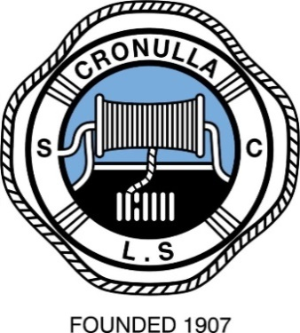

CRONULLA MASTERS 22nd ANNUAL
TWILIGHT TEAMS CARNIVAL

Friday 18th January 2019

Competition commences 5pm sharp

Events include: Swim Teams, Board Relay, Cameron Relay,
Board Rescue Relay, Ski, Taplin Relay, Beach Relay and Flags

Teams of Four: Must include either a Veteran (over 50) or a female.
All Competitors must be current financial members.

Club caps and pink hi-vis singlets are compulsory.

Entry: $60 per Team : NO late entries!
Includes food and first drink after competition.
Please complete entry form and fax/post/email pay:
Fax: (02) 9527 3847
Postal Address: PO Box 8 Cronulla NSW 2230
Email: admin@cronullasurfclub.com
Inquiries: (02) 9523 5300 – for payment information.
Masters Captain: Dave Brukmann 0411 751 907
davidbrukmann@gmail.com
……………………………………………………………………………..
ENTRY FORM
Competitors Name(s) Club Age (As at 1/10/18)
1 …………………….. ……………….. ……
2 …………………….. ……………….. ……
3 …………………….. ……………….. ……
4 …………………….. ……………….. ……
Contact name/phone/e-mail: …………………………………………….
Teams may be in two pools, (Pending final Team numbers) and will score points independently.
Competitors must provide their own craft and handlers.

NOTE: Club caps and pink hi-vis singlets are compulsory.
Program:
5.00 1km Beach Run (minimum 2 competitors)
5.10 Pool A Swim Teams (First 3 score points. Full Team of 4 can Swim)
5.20 Pool B Swim Teams (First 3 score points. Full Team of 4 can Swim)
5.30 Pool A Board Relay (3 paddlers. Must include either a Vet or Female)
5.40 Pool B Board Relay (3 paddlers. Must include either a Vet or Female)
5.50 Ski Race: Open Men (1 Paddler per Team)
6.00 Ski Race: Open Women (1 Paddler per Team)
6.10 Pool A Cameron Relay (1 Swimmer, 1 Paddler, 2 Runners)
6.20 Pool B Cameron Relay (1 Swimmer, 1 Paddler, 2 Runners)
6.30 Pool A Board Rescue Relay (2 Swimmers & 2 Paddlers)
6.45 Pool B Board Rescue Relay (2 Swimmers & 2 Paddlers)
7.00 Pool A Taplin Relay (1swimmer, 1 board paddler, 1 ski paddler, 1 Runner)
7.15 Pool B Taplin Relay (1swimmer, 1 board paddler, 1 ski paddler, 1 Runner)
7.30 Pool A Beach Relay (4 runners)
7.40 Pool B Beach Relay (4 runners)
7.50 Flags: Open Male (maximum 2 competitors from each Team for Flags)
7.55 Flags: Open Female
8.00 Flags: 30 - 49
8.05 Flags: 50 +
8.10 BBQ - Drinks - Presentation:

