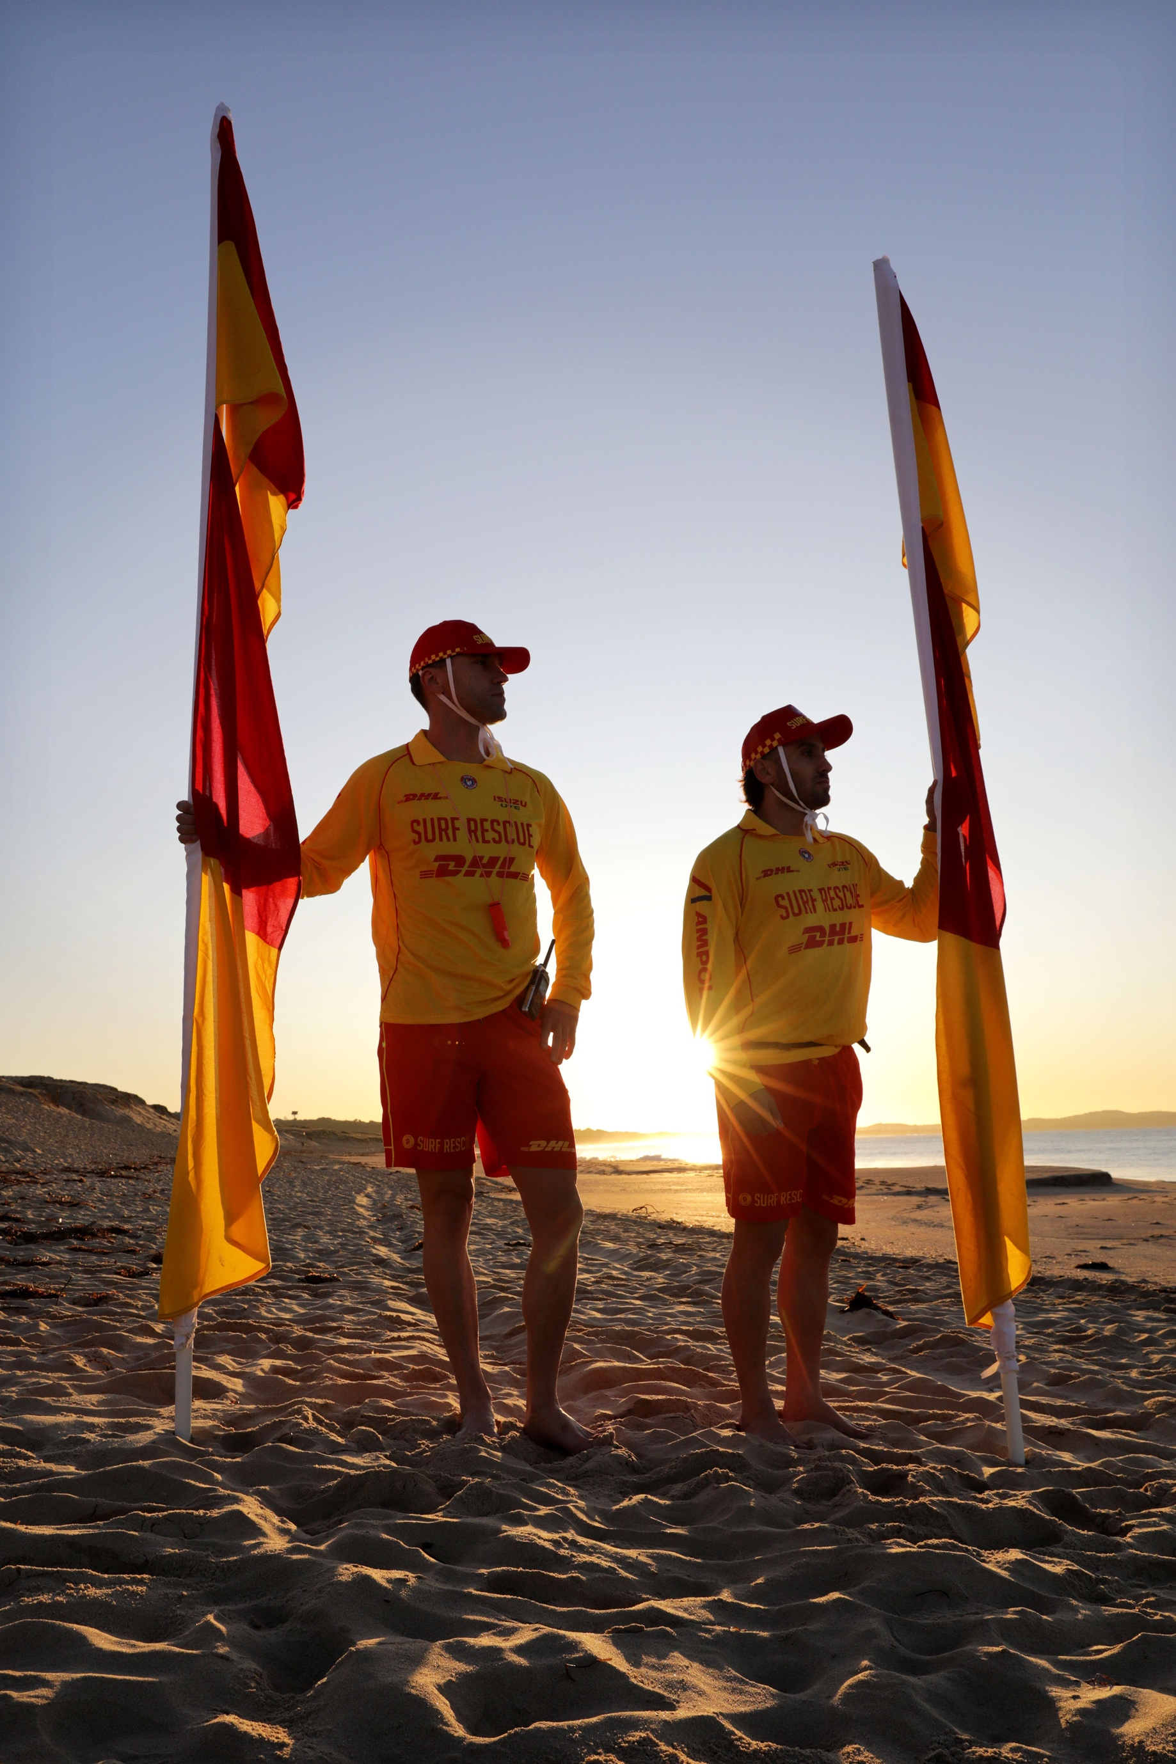

**Patrol Operations Manual**

**_______ SLSC**

**Table of Contents**

1. Patrol Operations 3
   1. Surf Life Saving & Emergency Services 3
   2. Club Radio Procedures 5
   3. Club Callout Team 6
2. Hazards & Dangers 7
   1. Beach Morphology & Hydrodynamics 7
   2. Hazard Map 8
   3. Hazard/Risk Management 8
3. Beach Management 10
   1. Equipment Location 10
   2. Local Government By-Laws 10
   3. Opening of Patrol (Start of Patrol) 10
   4. Closure of Patrol (End of Patrol) 11
   5. Nippers/Water Safety 11
4. Emergency Operations Plans 12
   1. Emergency Beach Closure 12
   2. Emergency Beach Closure Procedure 12
   3. Tsunami Plan 13
      1. Notification 13
      2. Key Equipment 14
      3. Marine Threat Response 14
      4. Land Threat Response 14
   4. Coastal Flooding Plan 15
      1. Coastal Flooding Response 15
   5. Emergency Rally Point 16
5. Standard Operating Procedures 17

# Patrol Operations

## Surf Life Saving & Emergency Services

|  |  |  |
| --- | --- | --- |
| **SurfCom** | | |
| **Service** | **Phone** | **Email** |
| SOC General Line | 02 9471 8092 | [soc@surflifesaving.com.au](mailto:soc@surflifesaving.com.au) |
| SOC Emergency Line | 02 9471 8091 |
| Emergency services such as Police, Ambulance, Fire, Helicopters, Roads and Maritime Services, Marine Rescue,  National Parks and Wildlife Services and the NSW Department of Primary Industries should be requested via SurfCom | | |

|  |  |
| --- | --- |
| **Location Details** | |
| Street Address: | _____________________ |
| What 3 Words: | ________ SLSC: *///___________*  4WD Access: *///__________*  Sea Wall: *///_________* |
| Nearest Cross Street: | __________ x _________ |
| Emergency Rally Point: | _____________________ |

|  |  |  |  |
| --- | --- | --- | --- |
| **Local Stakeholders** | | | |
| STAKEHOLDER | PHONE NUMBER | STAKEHOLDER | PHONE NUMBER |
| STAKEHOLDER | PHONE NUMBER | STAKEHOLDER | PHONE NUMBER |
| STAKEHOLDER | PHONE NUMBER | STAKEHOLDER | PHONE NUMBER |
| STAKEHOLDER | PHONE NUMBER | STAKEHOLDER | PHONE NUMBER |
| STAKEHOLDER | PHONE NUMBER | STAKEHOLDER | PHONE NUMBER |

|  |  |  |  |
| --- | --- | --- | --- |
| **Patrol Times 2024/2025** | | | |
| **Period** | **Date** | **Saturdays** | **Sundays + Pub Hol** |
| 1 | ________________ | ________________ | ________________ |
| 2 | ________________ | ________________ | ________________ |
| 3 | ________________ | ________________ | ________________ |
| 4 | ________________ | ________________ | ________________ |
| 5 | ________________ | ________________ | ________________ |

|  |  |  |  |
| --- | --- | --- | --- |
| **Patrol Times 2025/2026** | | | |
| **Period** | **Date** | **Saturdays** | **Sundays + Pub Hol** |
| 1 | ________________ | ________________ | ________________ |
| 2 | ________________ | ________________ | ________________ |
| 3 | ________________ | ________________ | ________________ |
| 4 | ________________ | ________________ | ________________ |
| 5 | ________________ | ________________ | ________________ |

|  |  |  |  |
| --- | --- | --- | --- |
| **Club Officer Details** | | | |
| **Club Position** | **Name** | **Phone Number** | **Email Address** |
| President | ________________ | ________________ | ________________ |
| Vice President | ________________ | ________________ | ________________ |
| Club Captain | ________________ | ________________ | ________________ |
| Vice Club Captain | ________________ | ________________ | ________________ |
| Gear Steward | ________________ | ________________ | ________________ |
| Radio Officer | ________________ | ________________ | ________________ |
| IRB Captain | ________________ | ________________ | ________________ |
| Board Captain | ________________ | ________________ | ________________ |
| Chief Training Officer | ________________ | ________________ | ________________ |
| Caretaker | ________________ | ________________ | ________________ |
| JA Water Safety Mgr | ________________ | ________________ | ________________ |
| Patrol 1 Captain | ________________ | ________________ | ________________ |
| Patrol 2 Captain | ________________ | ________________ | ________________ |
| Patrol 3 Captain | ________________ | ________________ | ________________ |
| Patrol 4 Captain | ________________ | ________________ | ________________ |
| Patrol 5 Captain | ________________ | ________________ | ________________ |
| Patrol 6 Captain | ________________ | ________________ | ________________ |
| Patrol 7 Captain | ________________ | ________________ | ________________ |
| Patrol 8 Captain | ________________ | ________________ | ________________ |
| Patrol 9 Captain | ________________ | ________________ | ________________ |
| Patrol 10 Captain | ________________ | ________________ | ________________ |
| Patrol 11 Captain | ________________ | ________________ | ________________ |
| Patrol 12 Captain | ________________ | ________________ | ________________ |

|  |  |  |
| --- | --- | --- |
| **Neighbouring Surf Life Saving Clubs** | | |
| **Surf Life Saving Club** | **Phone Number** | **Email Address** |
| ________________ | ________________ | ________________ |
| ________________ | ________________ | ________________ |
| ________________ | ________________ | ________________ |
| ________________ | ________________ | ________________ |
| ________________ | ________________ | ________________ |
| ________________ | ________________ | ________________ |
| ________________ | ________________ | ________________ |
| ________________ | ________________ | ________________ |
| ________________ | ________________ | ________________ |
| ________________ | ________________ | ________________ |

The SLSNSW State Operations Centre (SOC) standard operating hours shift throughout the year to accommodate seasonal variation in beach visitation and are subject to change. Contact soc@surflifesaving.com.au for most up to date operating hours.



From:

|  |  |  |
| --- | --- | --- |
| **23rd September 2024** | **0700hrs to 1800hrs** | **7 days a week** |
| **1st December 2024** | **0700hrs to 1900hrs** | **7 days a week** |
| **23rd February 2025** | **0700hrs to 1800hrs** | **7 days a week** |
| **1st May 2025** | **0700hrs to 1700hrs** | **7 days a week** |

**As an Emergency Service our lines are monitored 24/7.**

***All communications to and from the SOC are recorded, as per the SLSNSW Standard Operating Procedures.***

Outside of SOC operational hours phones are monitored for emergency communication by a rostered State Duty Oﬃcer oﬀ -site.

The following phone lines are **monitored 24/7:**

**13SURF Surf Emergency Response System**

*Reserved for exclusive use by external emergency services.*

***This Number is not to be distributed and not to be used by patrolling members or members of the public.***

**SLSNSW SOC Emergency line - 9471 8091 SLSNSW SOC General line - 9471 8092**

**In the event of an Emergency:**

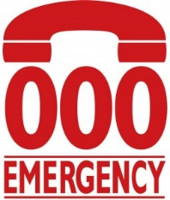During operational hours, contact Surfcom for 000 assistance.

For out-of-hours assistance, call 000 & notify the rostered State Duty Officer via 02 9471 8091

## A red and yellow sign with black text AI-generated content may be incorrect.Club Radio Procedures

## Emergency Callout Team

Due to the benefit to the community, all volunteer lifesaving services in NSW should have emergency response (24/7) callout capability. This should be achieved through a coordinated system of suitably qualified personnel with access to appropriate rescue equipment.

Members of the ‘Emergency Callout Team’ are to be appointed by the Club Captain with a list of active members (over the age of 18) maintained via SurfGuard.

To maximise emergency response effectiveness and personnel safety, clubs should maintain the following equipment/logistical preparedness at a minimum;

* *2 x rescue tubes (with fins)*
* *2 x rescue boards*
* *IRB (with trailer and full fuel bladder in an accessible location)*
* *SSV (if applicable)*
* *1 x defibrillator*
* *1 x oxy resuscitation kit*
* *1 x first aid kit*
* *1 x spinal board (with spinal collars)*
* *2 x handheld radios in waterproof bags*
* *Personal telephone numbers contactable 24 hours with contacts (updated in SurfGuard)*

Lifesaving services and/or personnel may decline a request to respond to an emergency if they feel it would create a level of unacceptable risk to do so. Examples of inhibitor may be:

* *Insufficient personnel*
* *Insufficient equipment*
* *Dangerous conditions*
* *Geographical distance (outside achievable response area)*

Appropriate local emergency response planning/preparedness (equipment and procedures) will minimise the above inhibitors and maximise the ability to render assistance.

# Hazards & Dangers

## Beach Morphology & Hydrodynamics

Insert ‘Beach Morphology and Hydrodynamics’ paragraph and image from your Surf Life Saving Club’s Supervision and Surveillance Report

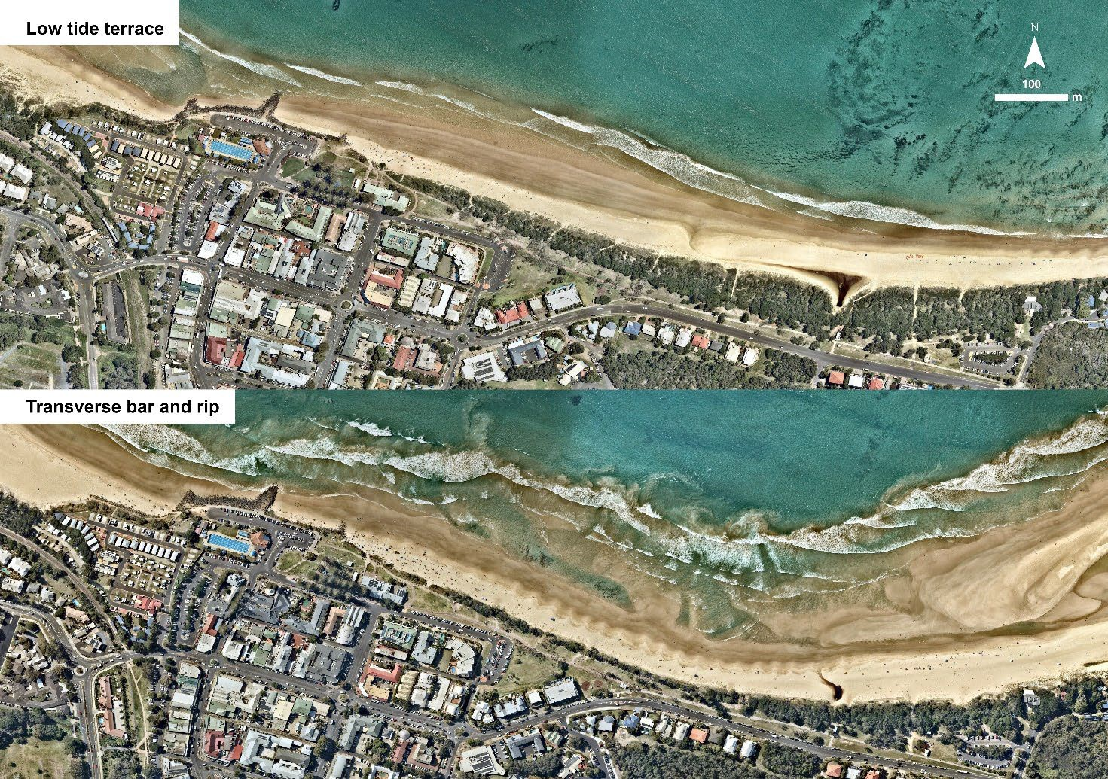

EXAMPLE

## Hazard Map

EXAMPLE

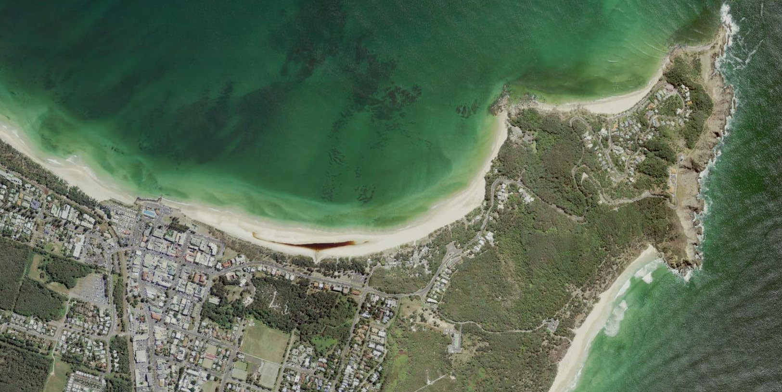

**Little Wategos**

**Wategos**

**Bullies Beach**

**The Pass**

**The Wreck**

**Cape Byron**

**Cosy Corner**

**Tallows Beach**

## Hazard/Risk Management

|  |  |
| --- | --- |
| **Hazard** | **Dangers** |
| ‘The Wreck’ | A large shipwreck approx. 400m North of the regular patrol area. A common place to snorkel and to climb and jump off into water. Dangers include:   * Large waves * Strong currents * Deep and/or shallow water * Sand banks * Rocks (Inc. submerged) * Poor visibility from the patrol area   EXAMPLE   * Large pieces of rusted metal under and above the water |
| Tallows Beach | Dangers include:   * Strong currents * Large waves * Sand banks |
| Cosy Corner | Situated at the most northern end of Tallow Beach, it is also on the southern end of Cape Byron. Dangers include:   * Strong currents * Large waves * Sharp rocks and ledges * Slippery rocks * Sand banks * Submerged rocks |

# 

# Beach Management

## Equipment Location

|  |  |
| --- | --- |
| **Item** | **Location** |
| IRB | _______ |
| Side-by-side vehicle | _______ |
| Radios | _______ |
| Patrol shade (tent) | _______ |
| Rescue boards | _______ |
| Rescue tubes | _______ |
| Defibrillator | _______ |
| Oxy resuscitation kit | _______ |
| First aid kit | _______ |
| Spinal board | _______ |
| Binoculars | _______ |
| Patrol flags/signage | _______ |

## Local Government By-Laws

|  |  |
| --- | --- |
| **Local By Law** | **Management Plan** |
| Dogs Prohibited on Beach | _______ |
| No Vehicles on Beach | _______ |
| No Alcohol on Beach | _______ |
| No Smoking on Beach | _______ |
| No Fires on Beach | _______ |
| No Camping or Overnight Stays | _______ |

## Opening of Patrol (Start of Patrol)

The flagged area should be located in the safest area for swimming and should be opened as wide as possible where conditions, activities and resources allow. The flags and rescue equipment must be moved with the rise and fall of the tide to keep them at the waters edge.

It is the responsibility of the Patrol Captain to ensure that all emergency equipment is in place and in working order. All patrolling equipment shall be checked on each deployment, with specific attention to the condition and operability of; power craft, rescue equipment, first aid and resuscitation equipment.

Any damaged or missing equipment shall be reported in the log, tagged and communicated ASAP to the Club Captain and/or Gear Steward.

|  |  |
| --- | --- |
| **Equipment Type** | **Necessary Checks** |
| Oxygen Resuscitation Kits | System test and miscellaneous equipment check.  Check oxygen cylinder is over ½ full.  It is strongly recommended that at least 1 full backup cylinder is available. |
| Defibrillators | System test and miscellaneous equipment check |
| First Aid Kits | Condition and contents check |
| Powercraft | Inflatable Rescue Boat (IRB) checks  Side-by-Side (SSV) Vehicle checks  4WD Vehicle checks |
| Rescue Equipment | Rescue board checks  Rescue tube and fins checks |
| Radios | Fully charged and operational  TWO radios to channel 2 (patrol) and TWO to channel 3 (SurfCom) |

## Closure of Patrol (End of Patrol)

When disestablishing the flagged patrol area, the following steps should be taken to ensure rescue readiness is maintained, and effective communication is utilized to ensure the safety of beachgoers;

1. Refer to Lifesaving Service Agreement and identify whether extended times (above minimum hours) are required due to patronage or conditions.
2. Inform SurfCom of closure or if extending patrol operations, notify Surfcom 30 mins prior.
3. Utilise the public announcer or similar to inform swimmers of closure and recommend they cease swimming for the day.
4. Utilise in-water lifesaving personnel to inform public of closure.
5. Consider a roving patrol to adjacent areas to inform public of closure.
6. Repeat communication of closure and warning of hazards to remaining swimmers if required.
7. Maintain surveillance of water while equipment is packed up for the day.
8. Maintain dedicated rescue equipment on-standby while other equipment is packed up for the day.
9. Prepare after-hour/call out response equipment (rescue-ready).
10. Conduct a final sweep of surf area before packing up standby equipment and leaving the beach.
11. Notify relevant club/service/branch officers/supervisors of any issues (i.e. Equipment damage, consumable/fuel shortages etc).

## Nippers/Water Safety

Nipper activities (and like activities) are to adhere to the SLSA Water Safety Policy (**SLSA Policy 1.01**) at all times. Nipper activities are to only be conducted in the immediate vicinity of an active patrolled area and have its own sufficient water safety (as detailed in SLSA Water Safety Policy 1.01A). It is highly recommended that an IRB be available water safety. The IRB should be on the water, rather than stationary on the beach.

Nipper water activities cannot be undertaken on a closed beach.

***NOTE****: the Patrol Captain/Lifeguard is the ultimate authority on the beach (notwithstanding Local and State Government requirements / Legislation).*

# Emergency Operations Plans

## Emergency Beach Closure

Patrol Captains should consider the ‘closure’ of a beach at any time that there is an unacceptable and/or unmanageable risk to the public or the lifesaving service is unable to effectively and safely perform their duties. For a detailed procedure, refer to Standard Operating Procedure ‘**PSS 8.1 Emergency Beach Closure and Evacuation**’.

Examples include;

* *IRB not operational*
* *Dangerous surf conditions*
* *Sharks*
* *Excessive stingers*
* *Powercraft hazards*
* *Lightning*
* *Tsunami/flood warning*
* *Storm pollution*
* *Chemical/fuel spill*

## Emergency Beach Closure Procedure

1. *Determine if water area is to be evacuated.*
2. *Log the beach closure through the Operations App (where available) and inform SurfCom via radio on channel 3 that you are about to close the patrolled area and the reason for closing.*
3. *Activate the Emergency Evacuation Alarm.*
4. *Inform everyone of the following:*
   * *Water area is being closed; and*
   * *Reason for closure.*
5. *Lower and remove the red and yellow patrol flags and black and white surfcraft flags.*
6. *Post ‘Swimming Not Advised’ signs at identified beach access points and where the flagged area was located.*
7. *Continually monitor all areas.*
8. *Maintain minimum personnel, qualification and equipment requirements.*
9. *Maintain an active presence on the beach to advise/warn public.*
10. *An appropriate record should be made in the patrol log giving an outline of the incident.*
11. *Where required liaise with Emergency Services*

Generally, the beach will remain closed until such time as the identified hazard is controlled or no longer presents a risk.

Recommended closure periods include;

* *Dangerous surf conditions – as determined/appropriate*
* *Shark sighting – at the discretion of the Patrol Captain and/or Duty Officer*
* *Chemical/biological hazards – after confirmation from appropriate authorities that the area is safe*

## Tsunami Plan

##### Surf Life Saving New South Wales is recognised under the State EMPLAN as a ‘support agency’ in a Tsunami event. Broadly, our role includes;

##### Contribute to tsunami community education initiatives

##### Assist the SES with the dissemination of warnings

##### Close and evacuate beaches on receipt of a NSW Tsunami Warning or upon observation of unusual ocean behaviour indicative of a tsunami, in consultation with Local Government Councils

##### Assist with the rescue of people from the surf zone following the impact of a tsunami

##### Notify the SES when unusual ocean behaviour indicative of a tsunami is observed or a tsunami has occurred for which there has been no prior warning

##### For a detailed procedure, refer to Standard Operating Procedure ‘**PSS 8.11 Tsunami Warning**’ and the ‘Surf Life Saving New South Wales Tsunami Plan.’

##### Each Surf Life Saving Club has an obligation to be prepared and respond as outlined in the ‘Surf Life Saving New South Wales Tsunami Plan’.

##### There are two types of tsunami threats;

##### Marine threat – may influence currents/rips/water energy and immediate foreshore (more common)

##### Land threat – may impact coastal areas, inlets and inland inundation (rare event, but significant impact)

### Notification

##### The SES is the ‘lead agency’ for tsunami response and will advise Surf Life Saving of a tsunami warning through the State Duty Officer, who will co-ordinate the Surf Life Saving response.

##### Due to the location of ‘fault lines’ (starting points of tsunami’s) a warning should precede the tsunami impact by a number of hours.

##### Depending on the time of day/year, the notification process will differ, however will remain similar to the standard emergency response notification;

**Patrols on duty**

##### State Duty Officer notifies SurfCom and Branch Duty Officer

##### SurfCom advises on duty patrols of tsunami warning and to activate their ‘Club Tsunami Response Plan’

**Patrols not on duty**

##### State Duty Officer notifies Branch Duty Officer

##### Branch Duty Officer notifies ‘Club Emergency Response Teams’ who activate their ‘Club Tsunami Response Plan’

### Key Equipment

##### The following equipment (minimum) is key to maintaining a viable lifesaving service during a tsunami warning (both marine and land threat) and restoring the service following the impact of a tsunami to a ‘rescue ready’ status. This equipment should be moved to a safe location prior to the tsunami’s impact (marine and land threat);

##### IRB (with trailer)

##### 3 x handheld radios in waterproof bags

##### 2 x ‘swimming not advised’ (or ‘beach closed) mobile signs

##### 1 x binoculars

### Marine Threat Response

##### Club advised of tsunami warning

##### Patrol/flagged area closed

##### Evacuation alarm sounded (continuous siren)

##### Evacuation flag erected (red and white quartered)

##### Swimmers/surfers etc evacuated from water

##### Members of the public evacuated from foreshore

##### ‘No swimming’ signage erected

##### Relocate key patrol/response equipment away from the foreshore

##### Prepare to evacuate all personnel and key equipment if warning is upgraded to a ‘land threat’

##### Maintain preparedness to respond to emergencies until threat has passed (official notification from SurfCom/Branch Duty Officer)

##### Upon clearance from SurfCom/Branch Duty Officer return to normal operations (stand down)

### Land Threat Response

##### Club advised of tsunami warning

##### Patrol/flagged area closed

##### Evacuation alarm sounded (continuous siren)

##### Evacuation flag erected (red and white quartered)

##### Swimmers/surfers etc evacuated from water

##### Members of the public evacuated from foreshore, car park and immediate area

##### ‘No swimming’ signage erected

##### All non-essential personnel sent home

##### Transport ‘key equipment’ and remaining personnel to pre-determined rally point (see 5.6 Emergency Rally Point)

##### Inform SurfCom/Branch Duty Officer when evacuation to rally point is complete

##### Maintain preparedness to respond to emergencies until threat has passed (official notification from SurfCom/Branch Duty Officer)

##### Respond to incidents following tsunami impact as directed by SurfCom/Branch Duty Officer

##### Upon clearance from SurfCom/Branch Duty Officer return to normal operations (stand down)

## Coastal Flooding Plan

Surf Life Saving New South Wales is recognised under the State EMPLAN as a ‘support agency’ in a coastal flooding event. Broadly, our role includes;

* *Assist the SES with the warning and/or evacuation of at risk communities*
* *Provide space in Surf Life Saving facilities for evacuation centres where required*
* *Assist the SES with flood rescue operation*

For a detailed procedure, refer to Standard Operating Procedure ‘PSS 8.10 Coastal Flooding.’

Each Surf Life Saving Club has an obligation to be prepared and respond in line with a ‘land threat’ tsunami warning.

Coastal areas are likely to be affected by either ‘flash flooding’ or ‘storm surge’ flooding. ‘Storm surge’ flooding will generally coincide with high tides and is easier to predict and prepare for. ‘Flash flooding’ is unpredictable and occurs in a short period of time, occasionally a storm warning may be issued prior to the flooding event.

#### Coastal Flooding Response

1. *Club advised of coastal flooding warning*
2. *Patrol/flagged area closed*
3. *Evacuation alarm sounded (continuous siren)*
4. *Evacuation flag erected (red and white quartered)*
5. *Swimmers/surfers etc evacuated from water*
6. *Members of the public evacuated from foreshore, car park and immediate area*
7. *‘No swimming’ signage erected*
8. *Prepare Clubhouse as an ‘emergency evacuation centre’*
9. *All non-essential personnel sent home*
10. *Transport ‘key equipment’ and remaining personnel to pre-determined rally point (see 5.6 Emergency Rally Point)*
11. *Inform SurfCom/Branch Duty Officer when evacuation to rally point is complete*
12. *Maintain preparedness to respond to emergencies until threat has passed (official notification from SurfCom/Branch Duty Officer)*
13. *Respond to incidents as directed by SurfCom/Branch Duty Officer*
14. *Upon clearance from SurfCom/Branch Duty Officer return to normal operations (stand down)*

## Emergency Rally Point

______________

What 3 Words: *///_________*

EXAMPLE

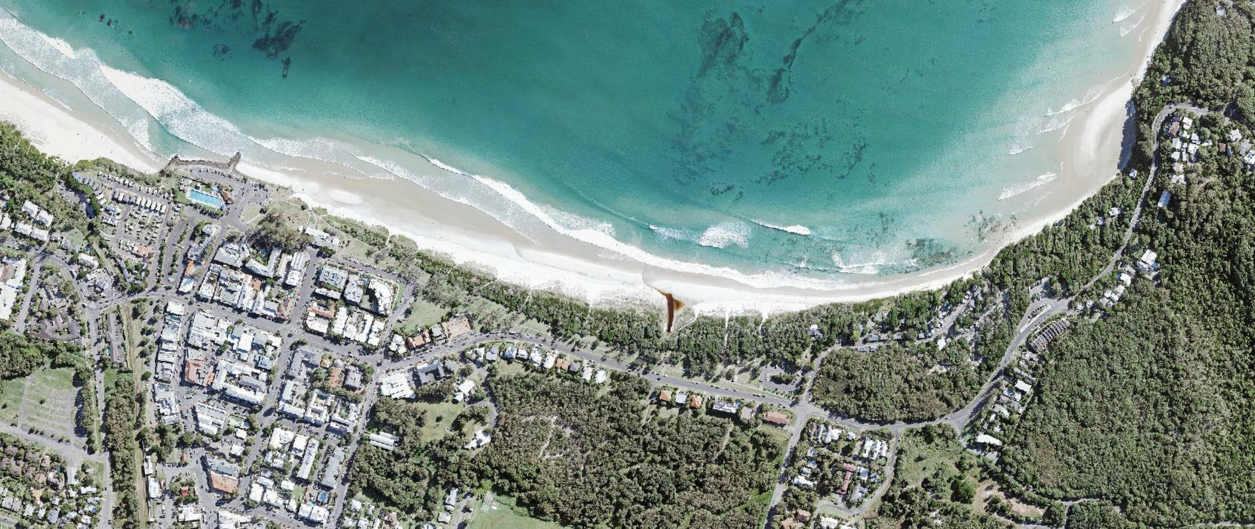

# Standard Operating Procedures

For detailed information on Lifesaving procedures and policies, refer to the [Public Safety Standard Operating Procedures](https://www.manula.com/manuals/slsnsw/pssops/jul.2023/en/topic/introduction) on the Surf Life Saving New South Wales website.

* [*PSS 1 Work Health and Safety*](https://www.manula.com/manuals/slsnsw/pssops/jul.2023/en/topic/pss1)
* [*PSS 2 Information Management*](https://www.manula.com/manuals/slsnsw/pssops/jul.2023/en/topic/pss-2-information-management)

**SLSNSW Public Safety**

**Standard Operations Procedures**

* [*PSS 3 Obligations and Standards*](https://www.manula.com/manuals/slsnsw/pssops/jul.2023/en/topic/pss-3-obligations-and-standards)
* 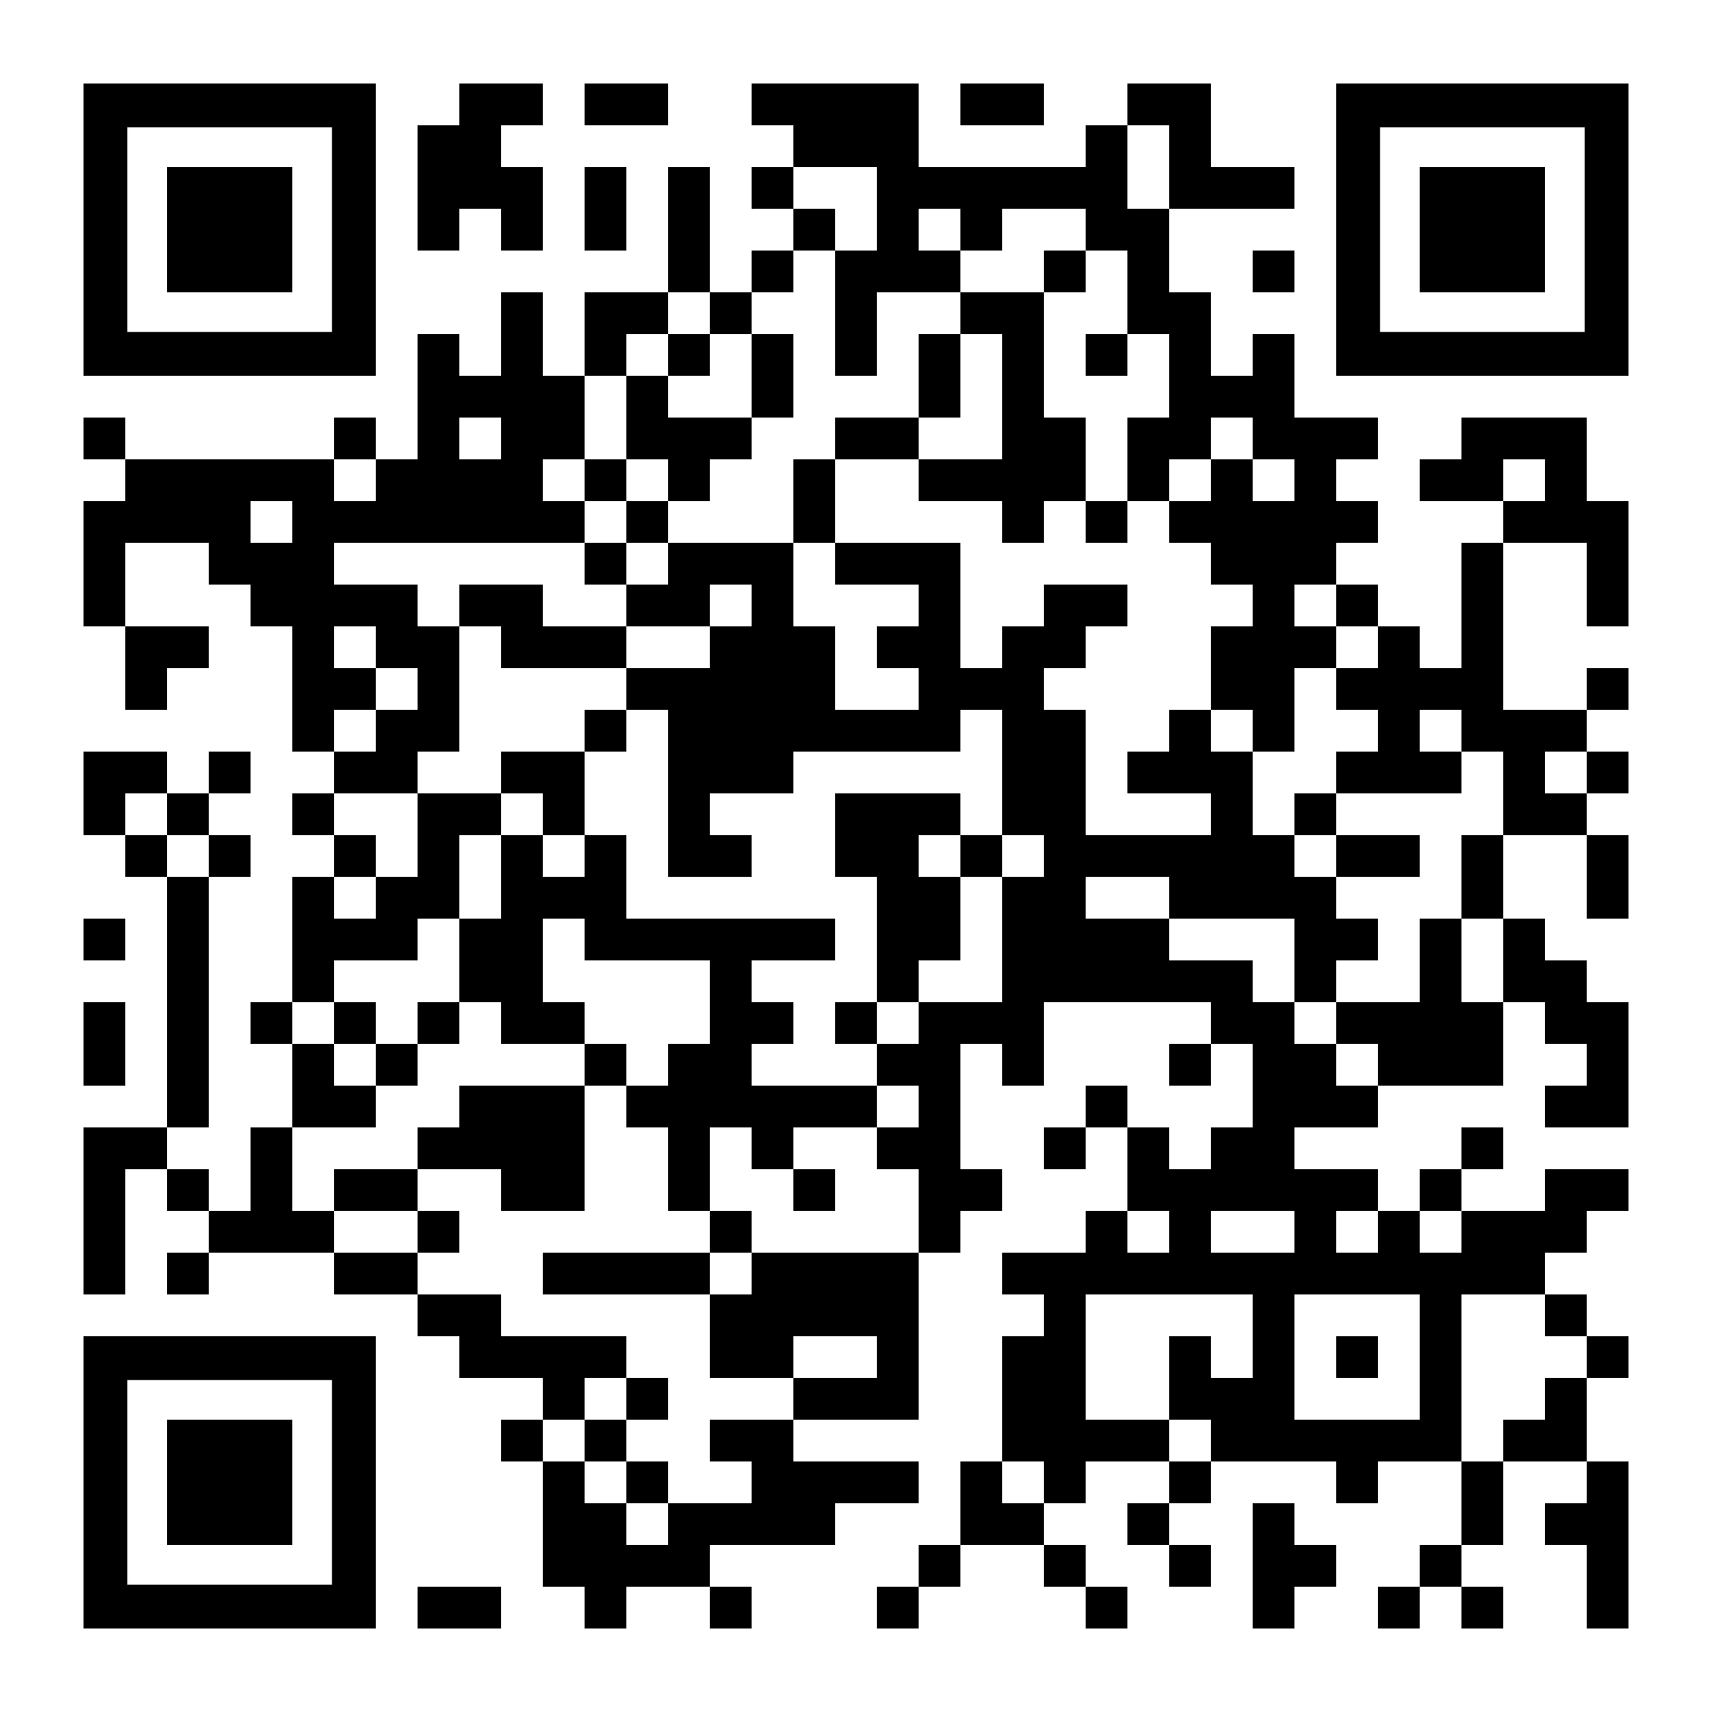[*PSS 4 Regulations – Rescue Vessels*](https://www.manula.com/manuals/slsnsw/pssops/jul.2023/en/topic/pss-4-regulations-rescue-vessels)
* [*PSS 5 Gear and Equipment*](https://www.manula.com/manuals/slsnsw/pssops/jul.2023/en/topic/pss-5-gear-and-equipment)
* [*PSS 6 Radio Communications*](https://www.manula.com/manuals/slsnsw/pssops/jul.2023/en/topic/pss-6-radio-communications)
* [*PSS 7 Patrol Operations (General)*](https://www.manula.com/manuals/slsnsw/pssops/jul.2023/en/topic/pss-7-patrol-operations-general)
* [*PSS 8 Patrol Operations (Emergency)*](https://www.manula.com/manuals/slsnsw/pssops/jul.2023/en/topic/pss-8-patrol-operations-emergency)
* [*PSS 9 Surf Emergency Response System*](https://www.manula.com/manuals/slsnsw/pssops/jul.2023/en/topic/pss-9-surf-emergency-response-system)
* [*PSS 10 SAR Operations*](https://www.manula.com/manuals/slsnsw/pssops/jul.2023/en/topic/pss-10-sar-operations)
* [*PSS 11 Surfcom*](https://www.manula.com/manuals/slsnsw/pssops/jul.2023/en/topic/pss-11-surfcom)
* [*PSS 12 Vessels and Aircraft*](https://www.manula.com/manuals/slsnsw/pssops/jul.2023/en/topic/pss-12-vessels-and-aircraft)
* [*PSS 13 Post-Incident*](https://www.manula.com/manuals/slsnsw/pssops/jul.2023/en/topic/pss-13-post-incident)